**AP PSYCHOLOGY**

**AHONEN**

**Join the Remind Account ASAP:**

* **Text:** 81010 **Message: @rahonen25**

**SUPPLY LIST**

Please try to have everything purchased and/or ordered by the first day of school.

**Specific**

* **Book: (see image below)**
  + **You ARE NOT REQUIRED to purchase your own book. I will issue books to issue students.**
  + Many students want to purchase their own textbook for various reasons.
  + If that is you:
    - We will be using Myers, D.G. (2018) Myers Psychology for the AP Course (3rd Edition). Bedford, Freeman and Worth.
    - You can purchase the book online at Amazon.com (<https://a.co/d/iCqm958>) and the approximate cost is $165.00 for a new book.
* **Class organization**
* Agenda/Calendar
* Paper
* 2-inch binder for class notes and activities.
  + Binders must be **subject specific; no sharing.**
* Blue ink pens
* Red pens
* #2 pencils
* Highlighter (s) any color
* Post it notes--any size and any color
* Desire to learn and always try your best

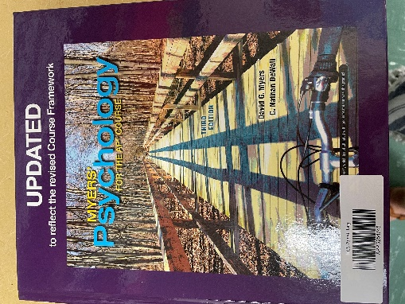

**AP PSYCHOLOGY**

**AHONEN**

**Join the Remind Account ASAP:**

* **Text:** 81010 **Message: @rahonen25**

**SUPPLY LIST**

Please try to have everything purchased and/or ordered by the first day of school.

**Specific**

* **Book: (see image below)**
  + **You ARE NOT REQUIRED to purchase your own book. I will issue books to issue students.**
  + Many students want to purchase their own textbook for various reasons.
  + If that is you:
    - We will be using Myers, D.G. (2018) Myers Psychology for the AP Course (3rd Edition). Bedford, Freeman and Worth.
    - You can purchase the book online at Amazon.com (<https://a.co/d/iCqm958>) and the approximate cost is $165.00 for a new book.
* **Class organization**
* Agenda/Calendar
* Paper
* 2-inch binder for class notes and activities.
  + Binders must be **subject specific; no sharing.**
* Blue ink pens
* Red pens
* #2 pencils
* Highlighter (s) any color
* Post it notes--any size and any color
* Desire to learn and always try your best

